|  |  |
| --- | --- |
| Layer Files (V7A prefix) | |
| L1/TopSignal/Component | CMP |
| L2/TopGround | LY2 |
| L3/Power Plane 1 | L3 |
| L14/Power Plane 2 | L14 |
| L15/BottomGround | L15 |
| L16/BottomSignal/Solder | SOL |
| Silk Screen CMP | PLC |
| Silk Screen SOL | PLS |
| Solder Stop Mask CMP | STC |
| Solder Stop Mask SOL | STS |
| Cream Frame CMP | CRC |
| Cream Frame SOL | CRS |
| Excellen Drill Data | DDD |

X-ray image of PCB displayed on next page.

**PCB DRAWING**

**Subsystem: MCAT | ASSY: MCAT-CANYVAL | P/N: T2 | REV: 5X | 201502241100**

**By Samudra Haque (**[**samudra@gwu.edu**](mailto:samudra@gwu.edu)**) and George Teel (gteel@gwu.edu), George Washington University, 2/23/2015**

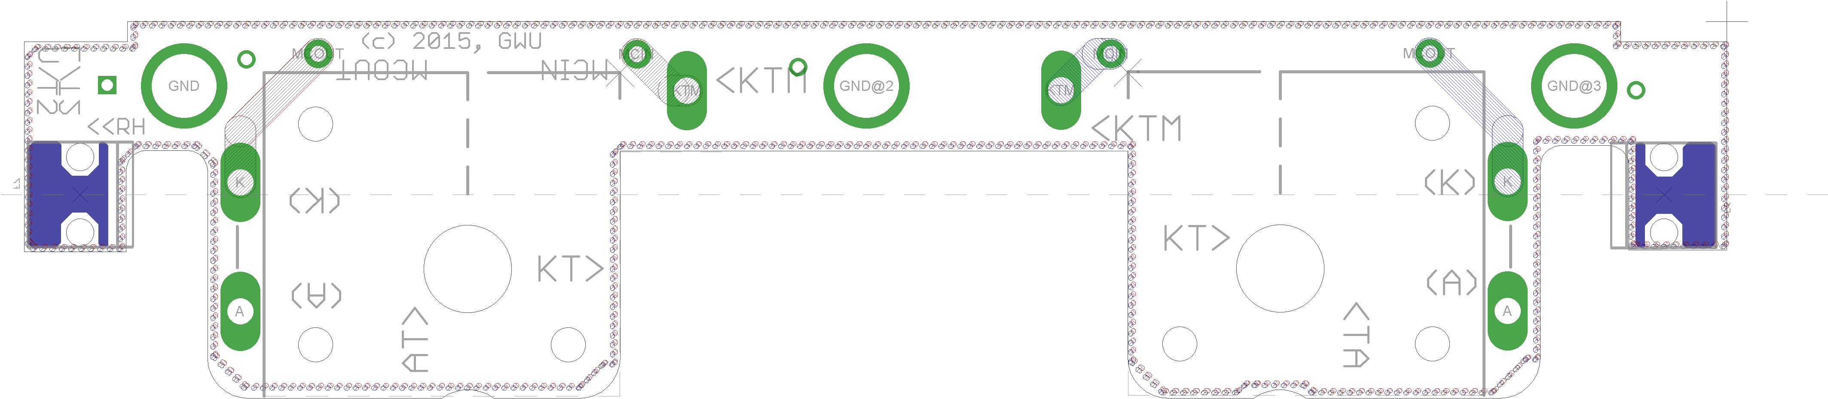

**Notes (unless otherwise specified)**

1. Fab per IPC-600G Class 2
2. Material
   1. Lead Free Assembly Compliant, ARLON 85NT or equiv.
   2. Finished Thickness to be 0.062” +/- .005”
   3. Total of 6 layers with 2 oz. CU ON ALL LAYERS.
3. Size: Cut and mill to outline shown; . Datum is TOP RIGHT CORNER MARKED WITH CROSS
4. DRILLING: DRILL HOLES PER SCHED. PLATE THROUGH HOLES WITH COPPER, 0.001” THICK MIN.
5. MILLING: PCB OUTLINE PROVIDED
6. ALL HOLE SIZES SPEC. AFTER PLATING.
7. HOLE LOCATION ToL. ARE +/- .003” IN REL. To CTR.
8. FINISH:
   1. HASL
   2. SOLDER MASK OVER BARE COPPER (**SMOBC**) USING Liquid PHOTO IMAGEABLE (**LPI**)
   3. COLOR: BOTH SIDES, COLOR BLUE,
   4. SILKSCREEN: WHITE.
9. GERBER LAYERS MAY BE NAMED DIFFERENT, BUT LAYERS 1,2,3,14,15,16 (top>BOTTOM)

Layer functions

L1/Top Signal/Top – 2 Oz Cu.

L2/Top Ground – 2 Oz Cu.

L3/Power Plane 1 – 2 Oz Cu.

L14/Power Plane 2 – 2 Oz Cu.

L15/Bottom Ground – 2 Oz Cu.

L16/Bottom Signal/Bottom – 2 Oz Cu.